RIPHAH INTERNATIONAL UNIVERSITY



Software Engineering

Project Title: Parking Lot Management System
Batch: Fall 2024

Project Team Members

Name of Students | Sap ID | Program | Email Address
Aina Mahboob | 63935 | BSSE | mahadktk405@gmail.com
Zara Rani | 65543 | BSSE | zararani133@gmail.com
Zaneera Bint-e-Zahid | 65326 | BSSE | zbz201105@outlook.com

Submitted to
Hafsa Javeed
Date of Submission
02/12/2025

Contents
Artifact#1: 5
1. Introduction 5
2. Purpose of the Project 5
3. Features of the Project 5
4. Technologies Used 5
5. Division of Responsibilities 6
Aina Mahboob 6
Zara Rani 6
Zaneera Bint-e-Zahid 6
6. Declaration of Team Consent 6
7. Conclusion 6
Artifact#2: 7
1. Software Development Model: Incremental Model 7
I. Reason for Selection 7
II. Description 7
III. Advantages for This Project 7
2. Scope of the Project 7
Artifact#3: 8
1. Introduction 8
1.1 Purpose 8
1.2 Document Conventions 8
1.3 Intended Audience and Reading Suggestions 8
1.4 Product Scope 8
1.5 References 8
2. Overall Description 9
2.1 Product Perspective 9
2.2 Product Functions 9
2.3 User Classes and Characteristics 9
2.4 Operating Environment 9
2.5 Design and Implementation Constraints 9
2.6 User Documentation 9
2.7 Assumptions and Dependencies 9
3. External Interface Requirements 10
3.1 User Interfaces 10
3.2 Hardware Interfaces 10
3.3 Software Interfaces 10
3.4 Communications Interfaces 10
4. System Features 10
4.1 Add Vehicle (Insertion) 10
4.2 Remove Vehicle (Deletion) 11
4.3 Display Parked Vehicles 11
4.4 License Verification 11
4.5 Parking Summary 11
5. Other Nonfunctional Requirements 12
5.1 Performance Requirements 12
5.2 Safety Requirements 12
5.3 Security Requirements 12
5.4 Software Quality Attributes 12
5.5 Business Rules 12
6. Other Requirements 12
Appendix A: Glossary 13
Appendix B: Analysis Models 13
Appendix C: To Be Determined (TBD) 13
Artifact#04: 14
UML Diagrams: 14
1. Use Case Diagram: 14
2. Sequence Diagram: 15
3. Activity Diagram: 16
4. Class Diagram: 17
5. ER Diagram: 18
Last Artifact: 19
Test Case 01:- 19
Add Vehicle - Valid Input: 19
Test Case 02:- 19
Add Vehicle – Illegal License Plate: 19
Test Case 03:- 20
Add Vehicle – Parking Full: 20
Test Case 04:- 20
Remove Vehicle – Valid Plate: 20
Test Case 05:- 21
Remove Vehicle – Not Found: 21
Test Case 06:- 21
Display Parked Vehicle: 21
Test case 07:- 22
Parking Summary: 22
Conclusion: 22

Artifact#1:

Introduction
The Parking Lot Management System is a smart parking management solution designed to manage and organize vehicle parking automatically. It digitally records of when vehicle entre and exits, allocates parking slots dynamically, and verifies vehicle legality based on predefined data.
The system scans each vehicle upon entry, detects the number of passengers, verifies license plate authenticity, and assigns parking slots accordingly. The project has been implemented in C++, using Data Structures and Algorithms (DSA) such as linked lists and queues to store and find vehicle information quickly and easily.

Purpose of the Project
The main purpose of this project is to develop an automated parking system that:
- Replaces manual record-keeping with a computerized, efficient process.
- Collects and stores important details about vehicle such as owner name, vehicle type, license plate, and time of entry.
- Identifies illegal or stolen vehicles by checking stored information.
- Saves time and effort for managing vehicle entries and exits.
- Ensures all parking slots are used fairly and maintains an accurate digital record of all vehicle.

Features of the Project
- Add Vehicle: Saves vehicle details (owner name, license plate, type, passengers) and assigns a parking slot.
- Scan Vehicle: Scans the vehicle to detect the number of passengers and verify license is valid.
- Remove Vehicle: Deletes vehicle record on exit and displays exit time.
- Display Parked Vehicles: Shows a list of all vehicles currently parked.
- License Verification: Checks if a vehicle’s license plate is legal or marked as stolen/illegal.
- Parking Summary: Displays total, filled, and available slots in real time.

Technologies Used
- Programming Language: C++
- Data Structures: Linked List, Queue, Array
- IDE Used: Dev-C++
- Data Storage: In-program variables (no external file handling)

Division of Responsibilities

Aina Mahboob
- Collected requirements and designed the vehicle data structure.
- Implemented and tested the linked list operations (insertion and deletion).
- Verified system accuracy and tested input/output of vehicle records.

Zara Rani
- Developed the logic for slot allocation and legality verification using arrays and queues.
- Ensured correct parking slot management and handled testing for scanning functionality.
- Assisted in documentation and preparing project flow diagrams.

Zaneera Bint-e-Zahid
- Designed the main menu interface and integrated all system modules.
- Implemented license plate verification, vehicle scanning, and summary display features.
- Conducted overall system testing, performance checks, and handled final report compilation.

Declaration of Team Consent
We Zaneera Bint e Zahid, Zara Rani and Aina Mahboob, members of the Parking Lot Management System Project Team, hereby confirm that all members contributed equally according to the assigned responsibilities.
Each member participated in design, coding, and documentation to ensure the project’s successful completion.
This document represents our collective and original work.

Conclusion
The Parking Lot Management System automatically handles vehicle parking and tracking. It uses Data Structures and Algorithms (DSA) into a real-world parking scenario, the system manages parking slot efficiently, accurate data storage, and legal verification of vehicles.
Its dynamic design, modular development approach, and scalability make it a solid foundation for future enhancements such as payment automation or IoT integration.
Overall, the project demonstrates both technical understanding and software engineering principles effectively.

Artifact#2:

Software Development Model: Incremental Model

Reason for Selection
The incremental model was used for this project because the project was developed in small, manageable steps, where each module (vehicle addition, removal, scanning, display, and legality check) was built and tested step by step. This allowed smooth progress, easy debugging, and continuous enhancement without changing the parts already finished.

Description
The Incremental Model divides the system development into multiple independent increments.
Each increment adds new functionality to the system after thorough analysis, design, and testing of the previous stage.
In this project:
- The first increment implemented the data structure for storing vehicles.
- The second increment added vehicle entry and exit functionalities.
- The third increment included license verification and passenger detection.
- The final increment integrated display and summary features to complete the working system.

Advantages for This Project
- Stepwise development: Each part of the system was designed and verified before moving to the next.
- Early results: A working prototype was available early in development.
- Easy debugging: Errors could be isolated and fixed in individual increments.
- Scalability: Additional modules (like payment systems or sensors) can be added later without redesigning the entire system.

Scope of the Project
The Parking Lot Management System stands out due to its integration of data structures with real-world parking management logic.
Its uniqueness lies in:
- Simulated vehicle scanning that detects passengers and verifies legality.
- Dynamic memory management using linked lists, allowing vehicles to be added or removed efficiently.
- Real-time slot allocation and availability tracking using queues.
- Simple, interactive menu-driven interface suitable for practical demonstration and future expansion.
This system can be extended to include payment modules, IoT-based entry sensors, or database connectivity for large-scale applications.

Artifact#3:

1. Introduction

1.1 Purpose
This Software Requirements Specification (SRS) defines the functional and non-functional requirements of the Parking Lot Management System, a parking management system developed in C++ using Data Structures and Algorithms.
The purpose of the system is to automate vehicle parking operations, including entry registration, slot assignment, legality checking, and exit processing.

1.2 Document Conventions
- Headings follow IEEE SRS formatting.
- Requirements are labeled as REQ-#.
- Text uses simple indentation for hierarchy and clarity.
- All requirements use plain English to ensure clarity.

1.3 Intended Audience and Reading Suggestions
This document is intended for:
- Developers and testers: To understand logic and test functionalities.
- Project manager/instructor: To review requirements and project scope.
- End users: To understand how the system works conceptually.
Readers should begin with Section 1 (Introduction), then proceed to Section 2 (Overall Description) and Section 4 (System Features).

1.4 Product Scope
The Parking Lot Management System is an intelligent parking system that uses linked lists and queues to manage vehicle entry, storage, and exit.
It simulates scanning to detect passengers and verifies license plates against stored illegal entries.
The system aims to:
- Simplify parking management.
- Reduce human error.
- Detect illegal/stolen vehicles.
- Maintain accurate real-time records of parked vehicles.

1.5 References
- IEEE SRS Template (Karl E. Wiegers, 1999).
- Parking Lot Management System C++ Project Code (2025, Developed by BSSE Students, Riphah IU).

2. Overall Description

2.1 Product Perspective
The Parking Lot Management System is a standalone console-based system developed using C++.
It does not depend on external hardware or databases.
The system simulates a real parking environment where vehicles are dynamically stored in memory using a linked list and their parking queue is managed logically.

2.2 Product Functions
- Add vehicle (capture details, scan, verify legality).
- Assign parking slot automatically.
- Display all parked vehicles.
- Remove vehicle and show exit time.
- Check license plate legality.
- Display parking summary.

2.3 User Classes and Characteristics
- System Operator: Manages entries, removals, and verifications. Basic computer knowledge required.
- Administrator/Instructor: Reviews logs, testing, and documentation.

2.4 Operating Environment
- Language: C++
- IDE: Dev-C++
- Platform: Windows 10 or later
- Data Handling: In-program memory (no file I/O)

2.5 Design and Implementation Constraints
- No external file or database used.
- Runs in a text-based console.
- Limited to small-scale simulation (about 10 vehicles).

2.6 User Documentation
A short user guide will be provided, including:
- Installation and compilation steps in Dev-C++.
- Menu navigation and feature descriptions.

2.7 Assumptions and Dependencies
- The system assumes all data is entered correctly by the user.
- Illegal plate numbers are predefined in code.
- The random passenger count simulates scanning.

3. External Interface Requirements

3.1 User Interfaces
- Console-based text interface.
- Menu-driven options:
  - Add Vehicle
  - Remove Vehicle
  - Display Parked Vehicles
  - Check License Plate
  - Show Parking Summary
  - Exit

3.2 Hardware Interfaces
- Standard computer keyboard for input.
- Monitor for displaying output.

3.3 Software Interfaces
- Runs in Dev-C++ IDE.
- Uses standard C++ libraries: <iostream>, <string>, <ctime>, <cstdlib>.

3.4 Communications Interfaces
- No network or communication protocols are required.
- System operates locally.

4. System Features

4.1 Add Vehicle (Insertion)

4.1.1 Description and Priority
Allows operator to add a new vehicle with its details, scans it, and allocates a slot.
Priority: High

4.1.2 Stimulus/Response Sequence
Stimulus: User selects “Add Vehicle” and enters details.
Response: System scans vehicle, detects passengers, checks legality, and assigns a slot.

4.1.3 Functional Requirements
- REQ-1: The system shall record owner name, license plate, and vehicle type.
- REQ-2: The system shall randomly generate passenger count between 1 and 5.
- REQ-3: The system shall mark vehicle legality after verification.

4.2 Remove Vehicle (Deletion)

4.2.1 Description and Priority
Removes vehicle record on exit and frees the slot.
Priority: High

4.2.2 Functional Requirements
- REQ-4: The system shall search the linked list by license plate.
- REQ-5: The system shall display exit time and confirmation message.

4.3 Display Parked Vehicles

4.3.1 Description and Priority
Shows list of all parked vehicles with their details.
Priority: Medium

4.3.2 Functional Requirements
- REQ-6: The system shall traverse the linked list to display all records.
- REQ-7: The system shall show total occupied and available slots.

4.4 License Verification

4.4.1 Description and Priority
Checks whether a vehicle’s license plate is legal.
Priority: High

4.4.2 Functional Requirements
- REQ-8: The system shall compare the entered plate number against predefined illegal plates.
- REQ-9: The system shall display “Legal” or “Illegal/Stolen.”

4.5 Parking Summary

4.5.1 Description and Priority
Provides an overview of total, occupied, and available slots.
Priority: Medium

4.5.2 Functional Requirements
- REQ-10: The system shall display parking statistics at any point.

5. Other Nonfunctional Requirements

5.1 Performance Requirements
- Should process each operation (add, remove, display) within one second.
- Supports up to 10 vehicles at a time.

5.2 Safety Requirements
- Only simulated operations; no hardware risk.
- System should handle invalid input safely.

5.3 Security Requirements
- Restricted to local use; no external network access.
- Illegal plates stored within program code.

5.4 Software Quality Attributes
- Usability: Simple console menu for beginners.
- Reliability: Uses dynamic memory to prevent overflow.
- Maintainability: Modular functions for each feature.
- Efficiency: Uses linked lists for dynamic storage.

5.5 Business Rules
- Only legal vehicles can remain parked.
- A vehicle must have a valid license plate and owner name.

6. Other Requirements
- The system can be extended to include payment, camera detection, or database storage in future versions.

Appendix A: Glossary
Term | Description
DSA | Data Structures and Algorithms
IDE | Integrated Development Environment
Linked List | Dynamic data structure for storing vehicles
Queue | Logical structure for slot management

Appendix B: Analysis Models
At this stage, only the conceptual analysis models have been defined.
The detailed diagrams such as the Class Diagram, Data Flow Diagram (DFD), and Use Case Diagram will be included in the upcoming Software Design Document (Artifact #2).
For now, the analysis models identified are:
- Class Diagram: will represent main classes such as Parking Manager and Vehicle.
- Flow Diagram: will show the process flow of vehicle entry, verification, parking, and exit.
(Note: These models are referenced here to indicate planned design deliverables.)

Appendix C: To Be Determined (TBD)
The following elements are planned for future versions of the project and will be included in later artifacts:
- Graphical User Interface (GUI): A front-end interface for user-friendly interaction.
- Database Integration: To store vehicle and owner data persistently.
- Payment and Ticketing Module: For automated fee calculation and receipts.
- Hardware Integration: Optional camera or sensor-based vehicle detection.
(These items are not part of the current artifact but are included to show future project scope.)

Artifact#04:

UML Diagrams:

Use Case Diagram:
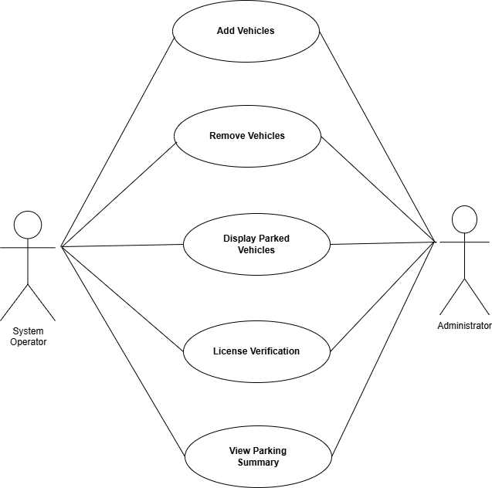

Sequence Diagram:
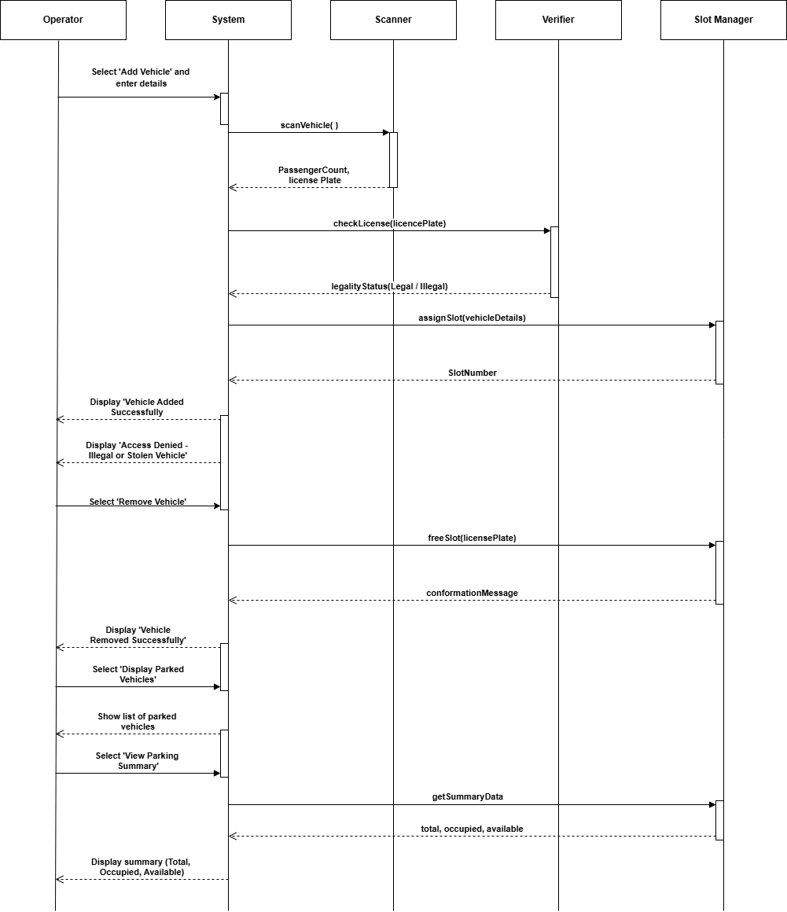

Activity Diagram:
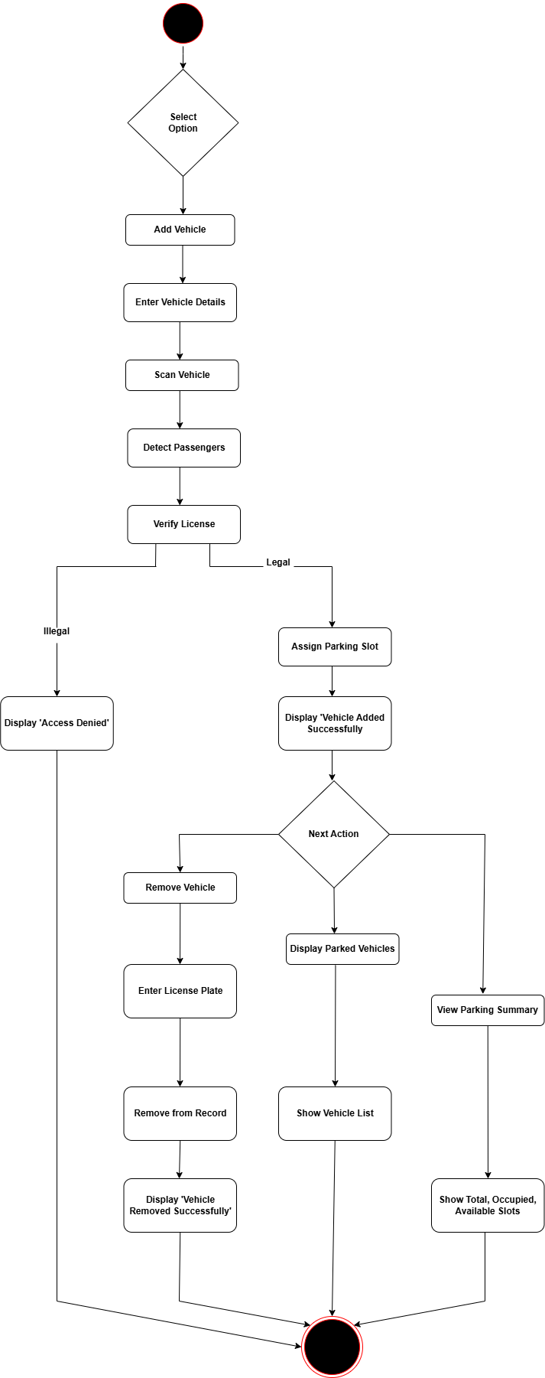

Class Diagram:
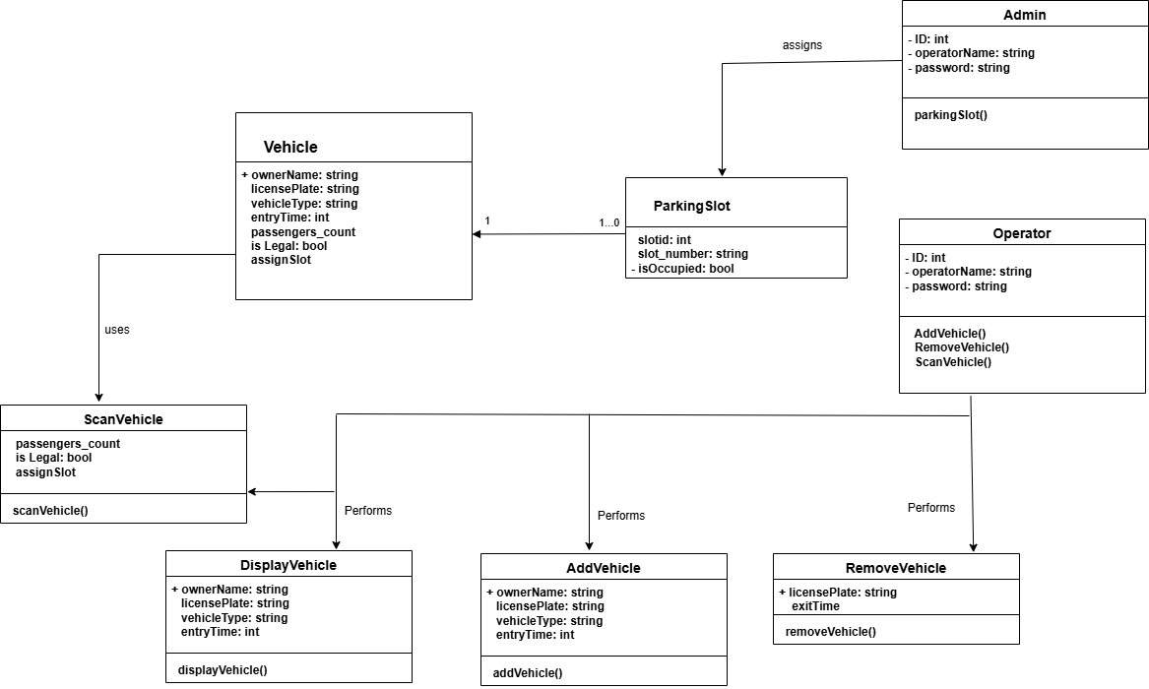

ER Diagram:
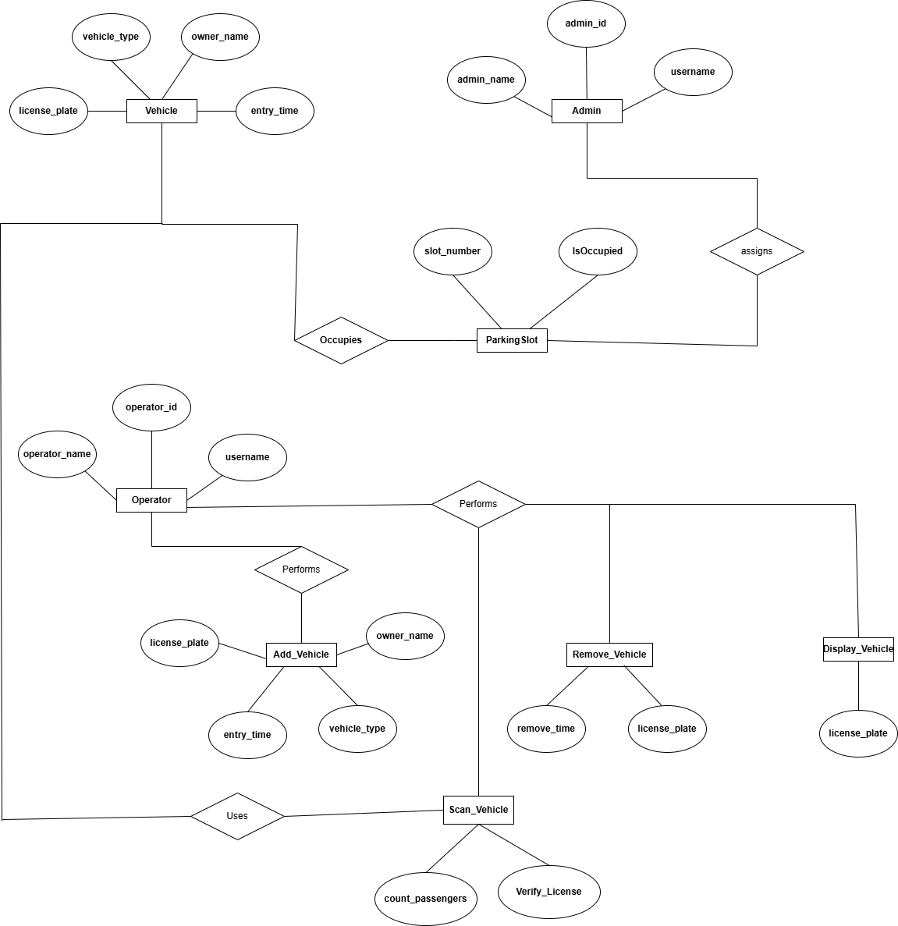

Last Artifact:

Test Case 01:-

Add Vehicle - Valid Input:
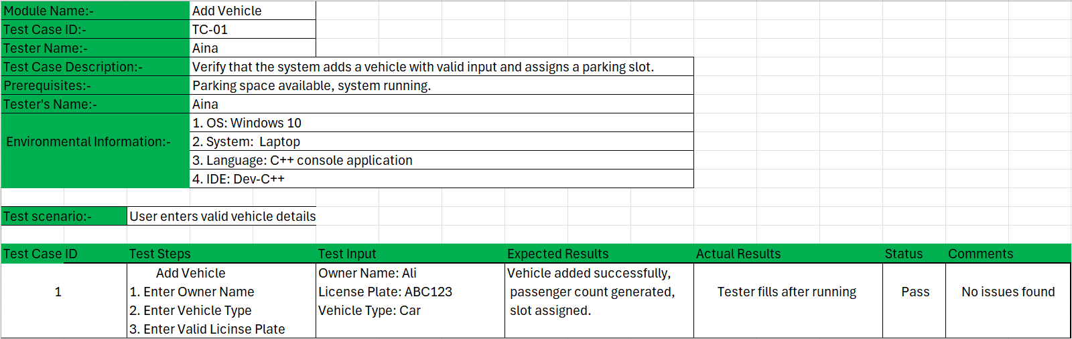

Test Case 02:-

Add Vehicle – Illegal License Plate:
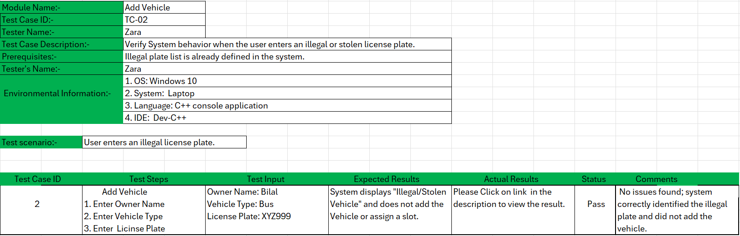

Test Case 03:-

Add Vehicle – Parking Full:
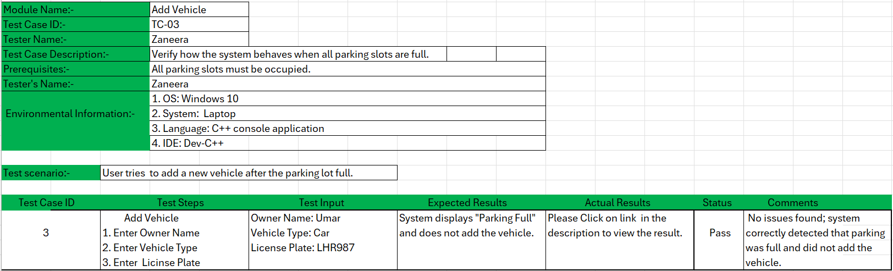

Test Case 04:-

Remove Vehicle – Valid Plate:
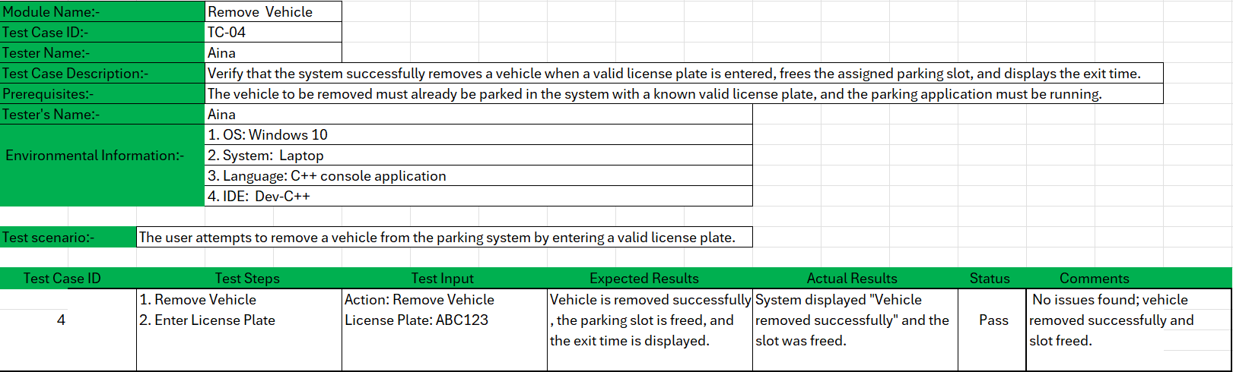

Test Case 05:-

Remove Vehicle – Not Found:
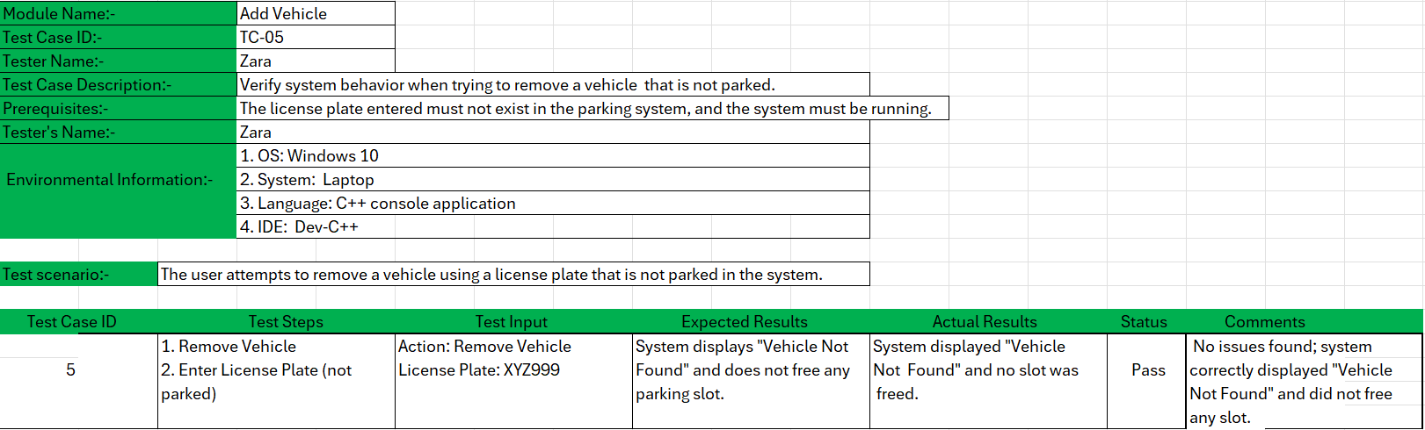

Test Case 06:-

Display Parked Vehicle:
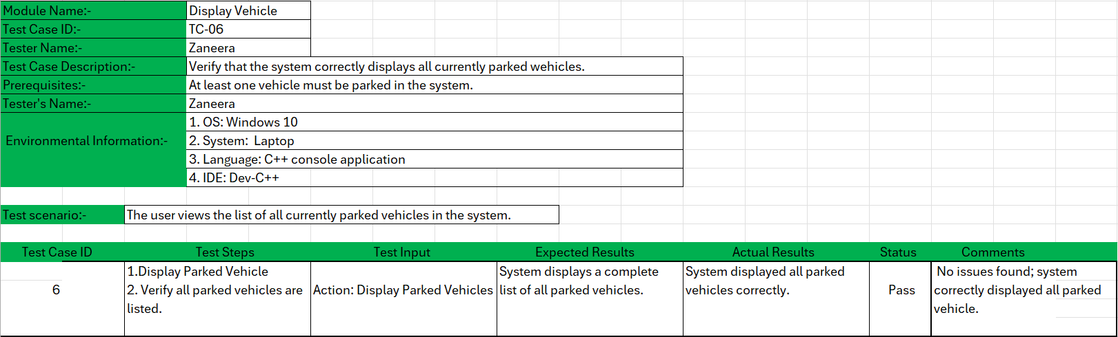

Test case 07:-

Parking Summary:
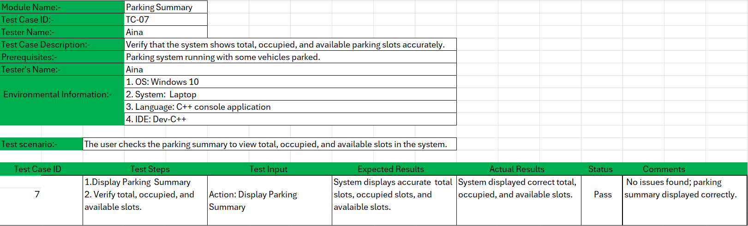

Conclusion:
All major functions of the Parking Management System – including adding vehicles, removing vehicles, displaying parked vehicles, and viewing the parking summary- were tested. All seven test cases passed successfully, and no major issues were found during testing.

_______________________________

